import java.sql.Connection;
import java.sql.PreparedStatement;
import java.sql.ResultSet;

public class CRUD_Test {

public static void main(String[] args) {

CRUD_Test objTest = new CRUD_Test();

// INSERT
objTest.create_data("201", "Arun", "arun@gmail.com");

// READ
objTest.read_data("201");

// UPDATE
objTest.update_data("201", "Arun Kumar", "arunkumar@gmail.com");

// DELETE
// objTest.delete_data("201");

// ALTER TABLE
// objTest.alter_table();

// TRUNCATE TABLE
// objTest.truncate_data();
}

// INSERT
public void create_data(String sl_no, String name, String email) {

DB_Connection obj_DB_Connection = new DB_Connection();
Connection connection = obj_DB_Connection.get_connection();

try {
String query = "INSERT INTO user(sl_no,name,email) VALUES(?,?,?)";

PreparedStatement ps = connection.prepareStatement(query);

ps.setString(1, sl_no);
ps.setString(2, name);
ps.setString(3, email);

int rows = ps.executeUpdate();

if (rows > 0) {
System.out.println("Record inserted successfully.");
}

} catch (Exception e) {
System.out.println(e);
}
}

// READ
public void read_data(String sl_no) {

DB_Connection obj_DB_Connection = new DB_Connection();
Connection connection = obj_DB_Connection.get_connection();

try {
String query = "SELECT * FROM user WHERE sl_no=?";

PreparedStatement ps = connection.prepareStatement(query);
ps.setString(1, sl_no);

ResultSet rs = ps.executeQuery();

while (rs.next()) {
System.out.println("Sl No : " + rs.getString("sl_no"));
System.out.println("Name : " + rs.getString("name"));
System.out.println("Email : " + rs.getString("email"));
System.out.println("----------------------");
}

} catch (Exception e) {
System.out.println(e);
}
}

// EDIT / VIEW SINGLE RECORD
public void edit_data(String sl_no) {

DB_Connection obj_DB_Connection = new DB_Connection();
Connection connection = obj_DB_Connection.get_connection();

try {
String query = "SELECT * FROM user WHERE sl_no=?";

PreparedStatement ps = connection.prepareStatement(query);
ps.setString(1, sl_no);

ResultSet rs = ps.executeQuery();

if (rs.next()) {
System.out.println("Sl No : " + rs.getString("sl_no"));
System.out.println("Name : " + rs.getString("name"));
System.out.println("Email : " + rs.getString("email"));
}

} catch (Exception e) {
System.out.println(e);
}
}

// UPDATE
public void update_data(String sl_no, String name, String email) {

DB_Connection obj_DB_Connection = new DB_Connection();
Connection connection = obj_DB_Connection.get_connection();

try {
String query = "UPDATE user SET name=?, email=? WHERE sl_no=?";

PreparedStatement ps = connection.prepareStatement(query);

ps.setString(1, name);
ps.setString(2, email);
ps.setString(3, sl_no);

int rows = ps.executeUpdate();

if (rows > 0) {
System.out.println("Record updated successfully.");
}

} catch (Exception e) {
System.out.println(e);
}
}

// DELETE
public void delete_data(String sl_no) {

DB_Connection obj_DB_Connection = new DB_Connection();
Connection connection = obj_DB_Connection.get_connection();

try {
String query = "DELETE FROM user WHERE sl_no=?";

PreparedStatement ps = connection.prepareStatement(query);
ps.setString(1, sl_no);

int rows = ps.executeUpdate();

if (rows > 0) {
System.out.println("Record deleted successfully.");
}

} catch (Exception e) {
System.out.println(e);
}
}

// TRUNCATE TABLE
public void truncate_data() {

DB_Connection obj_DB_Connection = new DB_Connection();
Connection connection = obj_DB_Connection.get_connection();

try {
String query = "TRUNCATE TABLE user";

PreparedStatement ps = connection.prepareStatement(query);

ps.executeUpdate();

System.out.println("All records deleted successfully.");

} catch (Exception e) {
System.out.println(e);
}
}

// ALTER TABLE
public void alter_table() {

DB_Connection obj_DB_Connection = new DB_Connection();
Connection connection = obj_DB_Connection.get_connection();

try {
String query = "ALTER TABLE user ADD COLUMN address VARCHAR(50)";

PreparedStatement ps = connection.prepareStatement(query);

ps.executeUpdate();

System.out.println("Column added successfully.");

} catch (Exception e) {
System.out.println(e);
}
}
}
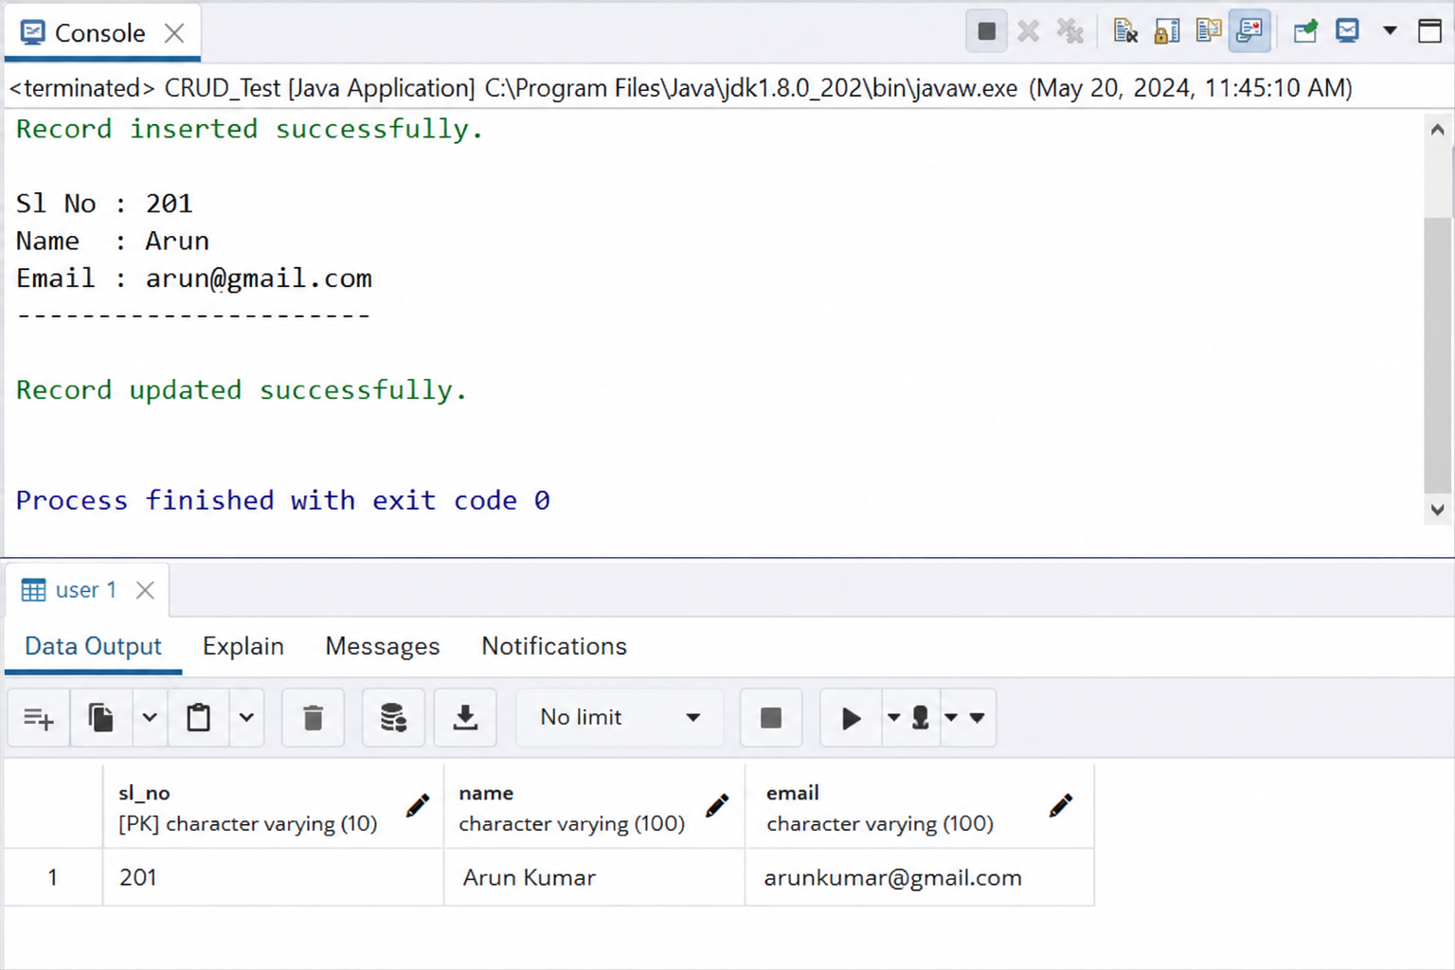
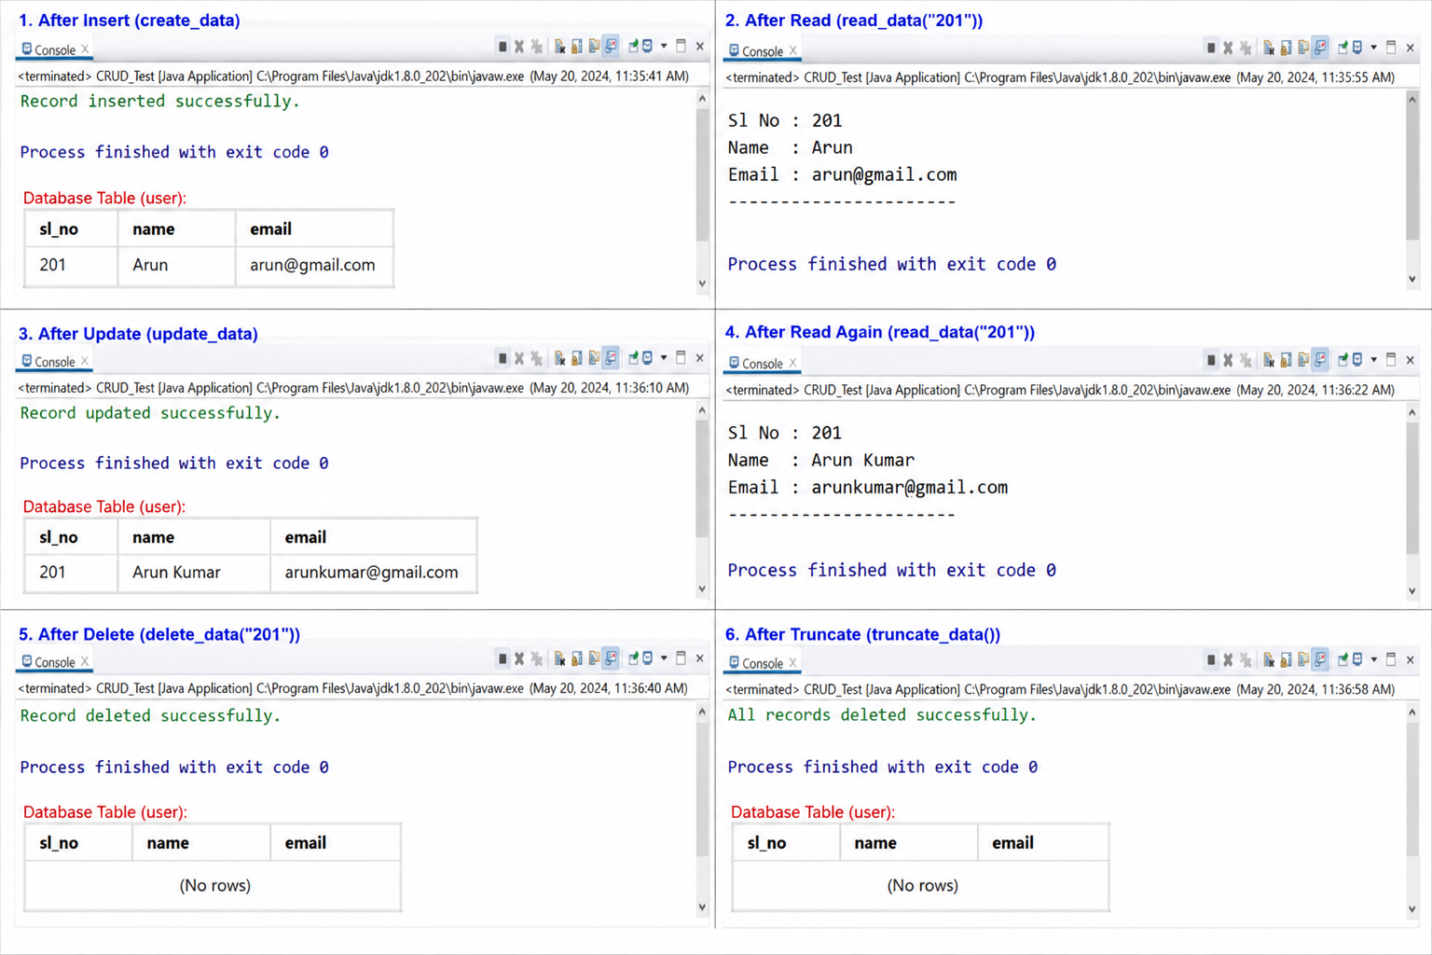

import com.mongodb.client.MongoClient;
import com.mongodb.client.MongoClients;
import com.mongodb.client.MongoDatabase;

public class MongoDBConnection {
public static void main(String[] args) {
String connectionString = "mongodb://localhost:27017";

try (MongoClient mongoClient = MongoClients.create(connectionString)) {
MongoDatabase database = mongoClient.getDatabase("testdb");
System.out.println("Connected successfully to MongoDB!");
}
}
}
